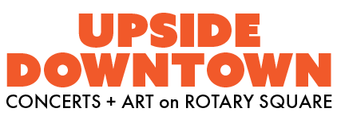
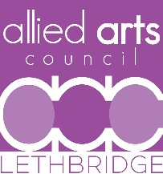
ARTIST SUBMISSION FAQ
- How can I improve my band’s chances of being selected?
To ensure your application is seen by the committee double-check that all your links to websites and socials are working and contact information is updated. Do you have an artist bio? A description of your band? Do you have lots of availability? Marketing materials?
Programming a concert series or festival is difficult as there are many aspects to be balanced in the decision-making; diversity of bands, music styles, availability, and affordability are some of the deciding factors. If you are not booked this year, please do not view it as a statement of the quality of your band but instead a reflection of our limited booking spaces. Please apply again.

- Is all the music at Upside Downtown original or can our band play covers?
The selection committee prioritizes original music. But some of the bands over the years have played covers. They are bringing their own artistic flavour to those songs which is appreciated by our audience.

- Does Upside Downtown only program local bands?
The concert series is a mix of local and Canadian bands. Most bands are drawn from southern Alberta, allowing us to support our local music scene. Out of town bands provide mentoring opportunities and also speak highly of the Lethbridge music community in other regions.

- What kind of genres are played at Upside Downtown?
Our audience loves live music. Throughout the years, the series has had Folk, Rock, R&B, Roots, Country, Punk, Soul, Dance, Surf, Blues, Retro and everything in between.

- Does Upside Downtown pay artists?
Yes, the Allied Arts Council believes that artists should be paid fairly for their work.

- I know a band! Can I recommend them?
Please share our artist submission link with any bands that you know. Please keep in mind that bands travelling from afar might not find it financially viable to play a 2 hour gig in Lethbridge without other nearby paid gigs. Touring in Canada is hard.

